**FETAL PIG DISSECTION**

**Developed by Dr. Mark Stanback**

**INTRODUCTION**

            In the following laboratory exercise, you will examine in some detail the external and internal anatomy of a fetal pig (*Sus scrofa*).  As the pig is a mammal, many aspects of its structural and functional organization are identical with those of other mammals, including humans.  Thus, a study of the fetal pig is in a very real sense, a study of humans.

            The fetuses you will use in the following weeks were salvaged from pregnant sows being slaughtered for food.  They are not raised specifically for dissection purposes.  The fetuses are removed from the sow and embalmed with a preservative, which is injected through the umbilicus.  Following this, the arterial and venous systems are injected under pressure with latex, a rubber-like compound.  Arteries (red) are injected through the umbilicus; veins (blue) are injected through one of the jugular veins at the base of the throat.

            With the possible exception of the abdominal cavity, organs rarely appear as they are presented in a diagram.  If the purpose of this exercise were simply to have you memorize diagrams (or computer screens), we would do only that and bypass the expense, time, and controversy of dissecting!  Dissection is a powerful teaching method, especially for concrete thinkers and visual learners.  Only by dissecting can you really appreciate the structural and functional role of the many membranes, mesenteries, and connective tissues that will impede your progress every step of the way.  Only by dissecting can you really appreciate the relationship between an organ's texture, location, and function.  I do not take the life (or death) of your pig specimen lightly – this is why I demand that you take your dissection seriously and utilize your pig to the fullest extent possible.

            During these exercises, keep several points in mind.  First, be aware that "to dissect" does not mean "to cut up," but rather primarily "to expose to view."  Actual cutting should be kept to a minimum.  Tissues are picked and teased apart with needle probes, forceps, and blunt probes in order to trace the pathways of blood vessels, nerves, muscles, and other structures. **Never cut or move more than is necessary to expose a given part.**  Second, pay particular attention to the spatial relationships of organs, glands, and other structures as you expose them.  Realize that their positions are not random.  Third, we encourage you to engage in collaborative discussions with your classmates and **compare dissections**.

            Although the structures described below are identified on the accompanying figures, in some cases the figures contain more information than you need to know.  Don't panic – this extra information is provided to help you identify what you do need to know.  If you wish to explore your pig more thoroughly and identify additional structures (e.g., blood vessels), please do!  Each lab group will be provided with a color photograph dissection manual to supplement this handout.  By the end of this exercise you should have a very good grasp of the connections between physiological processes and organ structure/function.

            At the end of each major section, we have produced a set of questions (**Think about it**). Additionally, there are boldface questions scattered through the text.  Make sure you figure out the answers to these questions before moving on.  All are fair game for the practical.

**SAFETY AND HYGIENE**

1.      Practice safe hygiene when dissecting.  Do not place your hands near your mouth or eyes while handling preserved specimens.  Although most of the preservatives in use today are non-toxic to the skin, they may cause minor skin irritations.  If the preservative gets on your skin, wash with soap and warm water.

2.      If the preservative gets in your eyes, rinse them thoroughly with the safety eyewash.

3.      Never splash the preservative in the pig buckets.

4.      Wear lab gloves.  Small, medium, and large sizes are available.  These gloves are expensive--please don't waste them.

5.      Lab gloves and paper towels go in the regular trash.  Skin and pieces of pig go into the red plastic bag at the front of the room (not down the disposal).

6.      After bagging your pig and placing it in the mortuary cabinet, rinse your tray and stack it neatly by the sink.  Wipe up your station.

**MATERIALS**

* fetal pig
* dissecting tray
* dissection kit (scissors, scalpel, blunt probe, needle probe, forceps)
* lab gloves
* paper towels
* string

**OBJECTIVES**

1.        Perform a whole-body dissection of a vertebrate.

2.        Identify the major anatomical features of the vertebrate body in a dissected specimen.

3.        Understand the relationship between structure and function in the vertebrate body and relate concepts covered in lecture to structures found in your pig.

4.        Understand mammalian fetal circulation from a mechanical, physiological, and evolutionary perspective.

5.        Apply knowledge and understanding acquired to problems in human physiology.

6.        Apply knowledge and understanding acquired to explain organismal adaptive strategies.

**I. EXTERNAL FEATURES**

1.      Determine the anatomical orientation of your specimen.

* *dorsal:  toward the back of the body
* *ventral:  toward the underside of the body
* *anterior (cranial):  toward the head end of the body
* *posterior (caudal):  toward the tail end of the body
* lateral:  to the side of the body
* median:  toward the center of the body
* right and left:  the pig's right and left, not yours!
* proximal or basal:  closer to the trunk
* distal:  farther from the trunk
* superficial:  lying closer to the body surface
* deep:  lying under or below

*The terms anterior and posterior are sometimes used synonymously with ventral and dorsal, respectively, for humans.

2.      Note the thin peeling layer of tissue covering the body of your pig.  This layer is the epitrichium, a layer of embryonic skin that peels off as hair develops beneath it.

3.        Identify the regions of the body (Fig. 1):

* head (cranial) region
* neck (cervical) region
* trunk region (thoracic region)
* tail (caudal) region (abdomoninal region)

4.        Head:  Find the following:

* pinna (auricle):  external ear
* external nares (nostrils)
* upper and lower eyelids
* nictitating membrane (third eyelid)

5.        Trunk:  The terms sometimes used to describe the trunk vary whether one is discussing the dorsal or ventral surface.  The trunk can be described using the terms associated with the vertebral column:  thoracic (rib), lumbar (lower back), and sacral (pelvic) vertebrae.  Ventrally, the abdominal region dominates the area posterior to the thorax.  Note the umbilical cord; it connects the fetus to the placenta of the mother and later becomes the navel.  Cut off the very tip (0.5 cm) of the umbilicus to more clearly see the following:

* umbilical arteries:  two arteries, carry deoxygenated blood from fetus to placenta
* umbilical vein:  a single large vein, carries oxygenated blood from placenta to fetus
* allantoic duct:  channels urine to the allantois, an extra-embyronic sac

6.        Appendages:  Examine the legs of your pig.  Find the following:

* On the forelimb find the shoulder, elbow, wrist, and digits.
* On the hindlimb find the hip, knee, ankle, heel, and digits.

7.        Determining the sex of your pig:

1. Female:  Look for a single urogenital opening just ventral to the anus.  A prominent genital papilla projects from the urogenital opening.
2. Male:  Look for the scrotum, a sac-like swelling containing the testes and located ventral to the anus.  The male urogenital opening is faintly visible just posterior to the umbilicus.  Note that males as well as females have multiple nipples = teats = mammary papillae.

**Think about it????**

1.      Notice how the number of toes is reduced in your pig.  The middle two digits form hooves.  Ungulates (hooved animals) like the pig walk with the weight of the body borne on the tips of the digits (unguligrade locomotion).  Cats and dogs use digitigrade locomotion (walking on the balls of their feet).  Humans typically use the entire foot for walking (plantigrade locomotion).  What form of locomotion do you use when you sprint?

2.      Although male mammals have nipples, as a general rule they do not lactate.  From an ultimate (why?) rather than a proximate (how?) standpoint, why is male lactation the exception rather than the rule (HINT: there are very few monogamous mammals)?

**II. DIGESTIVE SYSTEM**

**Objectives:**

1.      Identify and describe the **functions** of the main organs of the digestive system.

2.      Gain an appreciation of the spatial relationships of the many organs and structures that contribute to the digestion of food and the nourishment of the body's cells.

            The digestive system of mammals consists of the alimentary canal (mouth, oral cavity, pharynx, esophagus, stomach, small intestine, large intestine, rectum, anus) and other associated structures/organs/glands (salivary glands, gall bladder, liver, pancreas).

            The cavity behind the teeth and gums is the oral cavity.  Note the papillae on the tongue.  These provide friction for food handling and contain taste buds.  Like all young mammals, fetal pigs have milk teeth (baby teeth) that are later replaced by permanent teeth.

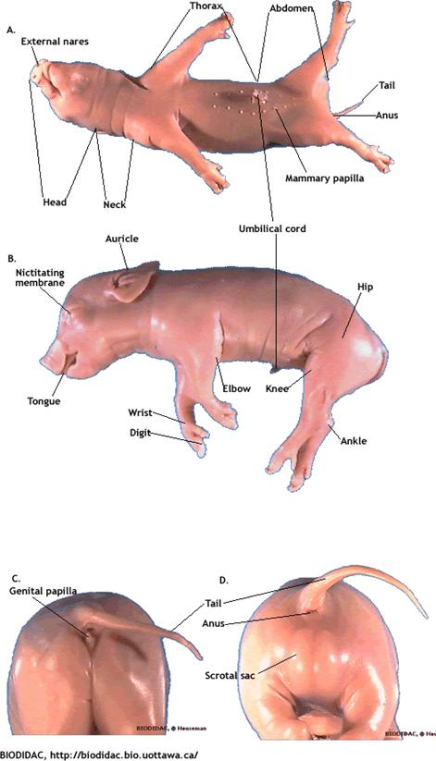

**Figure 1.** External anatomy of the fetal pig. A.  Ventral view.  B.  Lateral view.

C. Posterior view of female.  D.  Posterior view of male.

            There are 3 pairs of salivary glands (Fig. 2).  Of these, we will view only the mandibular (the parotid is rather diffuse and the sublingual is too difficult to get to). To view the mandibular gland you must remove the skin and muscle tissue from one side of the face (cheek) and neck of your pig.  You’ll need to dig through subcutaneous fat, connective tissue, and the parotid salivary gland in order to see it.  The mandibular gland is a large, well-defined circular salivary gland just posterior to the masseter.  Don’t confuse it with the small oval lymph nodes in the region.  Keep an eye out for the facial nerve that runs posteriorly across the masseter.  Try to find the parotid duct that carries saliva to the corner of the mouth.  This duct can be moved surgically to empty out at the eyes.  Until relatively recently, the standard "cure" for dogs whose lacrimal (tear) glands failed to produce the watery component of tears was to move the parotid duct up!  The saliva producing glands are:

* Parotid gland:  a large dark triangular gland overlying part of the masseter muscle (also note the facial nerve that runs across the dorsal part of the masseter).
* Mandibular gland:  under the parotid gland.  Not to be confused with the small oval lymph nodes in the region.
* Sublingual gland:  long, slender, and difficult to locate (so don't bother).
* Salivary glands produce prodigious amounts of saliva (>1 l/day in humans).  Saliva contains:
  + water for moistening food
  + mucus (mucin) for lubricating food and binding it into a bolus
  + salivary amylase to start the breakdown of starch
  + bicarbonate to buffer acidic food in the mouth
  + antibacterial agents to kill bacteria in the mouth

            With scissors, carefully cut through the tissue and bone starting at the corners of the mouth and back toward the ears (keeping the roof of the mouth intact) until the lower jaw can be dropped and the oral (buccal) cavity exposed (Fig. 3).

Find the following structures:

* hard palate:  has ridges; separates the oral cavity from the nasal cavities
* soft palate:  soft because there is no bone underneath (nasopharynx lies above it)
* buccal cavity:  from opening of mouth to the base of the tongue
* pharynx:  (throat) common passageway for digestive and respiratory system
* esophagus:  tube connecting oral cavity to stomach.  Swallowing can be initiated voluntarily, but thereafter it is a reflex controlled by a brain region.
* glottis:  the opening to the larynx
* epiglottis:  the flap that covers the glottis during swallowing
* Eustachian tubes:  may be visible on each side of the pharynx.

**Internal Anatomy of Digestive System**

            As you prepare to open up your pig, remember that most internal organs, including the digestive system, are located in the body cavity, or coelom.  A large muscular structure, the diaphragm, divides the mammalian body cavity into the thoracic cavity and the abdominal (peritoneal) cavity.  The thoracic cavity is further divided into a pericardial cavity (heart) and two pleural cavities (lungs).  Epithelial membranes line these cavities and cover the surface of all organs.  Names of the epithelial linings are determined by their location.  The word "parietal" refers to the wall of the body, and the word "visceral" in this case refers to organs within those cavities.

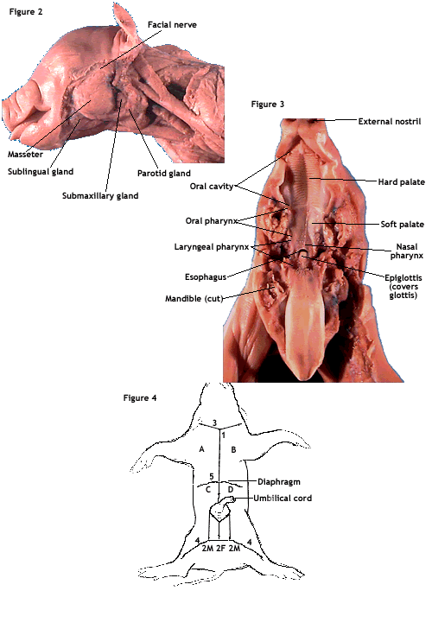

**Figures 2, 3, and 4.**  Salivary glands and neck region (Figure 2), oral cavity (Figure 3), and incision guide (Figure 4).

For example:

* visceral peritoneum:  covers organs of the peritoneal cavity
* parietal peritoneum:  lines peritoneal cavity
* visceral pericardium:  covers surface of heart
* parietal pericardium:  lines pericardial cavity
* visceral pleura:  covers surface of lungs
* parietal pleura:  lines pleural cavity

Coelomic fluid fills the space between membrane layers.  This moisture acts as a lubricant, allowing organs some degree of easy movement.  The organs are connected to each other and to the inner body wall by thin sheets of connective tissue called mesenteries, which suspend the organs and provide bridges for blood vessels, nerves, and ducts.

Use Figure 4 as a guide for making the various incisions.

1.  Begin your incision at the small tuft of hair on the upper portion of the throat (1) and continue the incision posteriorly to approximately 1.5 cm anterior to the umbilicus.  You should cut through the muscle layer, but not too deeply or you will damage internal organs.

2.  Whether your pig is male or female, make the second incision (2M) as a half circle anterior to the umbilicus and then proceed with two incisions posteriorly to the region between the hindlimbs.  Do not make the 2F incision.  If you have a male, be careful not to cut deeply into the scrotum.

3.  Deepen incisions 1 and 2 until the body cavity is exposed.  Make incisions 3 and 4 to produce lateral flaps that can be folded back.  Pour excess fluid into the waste container and rinse out the body cavity.

4.  Just below the lower margin of the rib cage, make a fifth (5) incision laterally in both directions.  This should expose the diaphragm, which separates the thoracic and abdominal cavities.  Using your scalpel, free the diaphragm, but do not remove it.

5.  Carefully peel back flaps A, B, C, and D and pin them beneath your pig.  It may be necessary to cut through the ventral part of the rib cage (very carefully) with a pair of scissors to separate flaps A and B.

6.  Carefully remove any excess latex. To free the umbilicus, cut through the umbilical vein approximately 1 cm from where it enters the liver.  Flap E can now be laid back and pinned.  Do not cut off this flap--it contains important organs that we will examine later!!

            Examine the neck, thoracic, and abdominal regions of your pig (Fig. 5).  First find the thymus gland, which partially covers the anterior portion of the heart and extends along the trachea to the larynx.  The thymus plays an important role in the development and maintenance of the immune system – this is where white blood cells mature into antibody-producing T-lymphocytes.

            Immediately beneath the thymus in the neck is the thyroid gland, a small,solid, reddish, oval mass.  The thyroid secretes thyroxine, which in mammals influences the metabolic rate of cells, which in turn influences growth and development.  Because iodine is necessary for the production of thyroxine, our salt is often iodized.  If synthesis of thyroxine declines (e.g. due to a lack of iodine), the anterior pituitary increases the release of thyroid stimulating hormone (TSH).  This may stimulate the proliferation of thyroid cells, but if there is no iodine, thyroxine production will not increase, which causes additional TSH release.  The thyroid also produces calcitonin, a hormone that stimulates osteoblasts to lay down bone.  The consequence of this activity is a surprisingly rapid decline in blood calcium levels.  If blood Ca levels drop too low, or if extra Ca is needed, the parathyroid glands release parathormone.  The parathyroid is not a discrete organ in mammals – parathyroid tissue is embedded in the thyroid.  Parathormone raises blood Ca levels by activating osteoclasts, by stimulating Ca resorption in the kidney, and by activating vitamin D to enhance absorption of Ca from food.

            In the neck find the trachea and use it as a landmark to locate the esophagus.  Make a small incision in the esophagus in the throat and insert a blunt probe anteriorly; note where it emerges in the oral cavity.

            Insert the blunt probe through this incision posteriorly toward the stomach (you will need to move the liver to one side to fully expose the stomach).  Note that the esophagus penetrates the diaphragm before entering the stomach.  Cut open the stomach lengthwise with your scissors.  The contents of a fetus's digestive tract is called meconium, composed of a variety of substances including bile stained mucus, amniotic fluid, sloughed epithelial cells, and hair. Clean out the stomach and note the folds (rugae).  **What role might the rugae play?**  Many glands that secrete pepsinogen and hydrochloric acid are embedded in the wall of the stomach.

            Two muscular rings (smooth muscle), the cardiac (closer to the heart) and the pyloric sphincter (adjoining the small intestine), control the movement of food through the stomach.

            The majority of digestion and absorption takes place in the small intestine.  It is composed of the duodenum, the jejunum, and the ileum, the latter two being difficult to distinguish.  The duodenum, into which bile and enzymes from the gall bladder and pancreas enter, passes posteriorly and then curves to the left.  The coils of the small intestine are held together by mesenteries.  A rule of thumb is that the small intestine in both pigs and humans (omnivores) is about five times the length of the body.  Note the lymph nodes embedded in the mesenteries.  These nodes filter pathogens from the lymph.

Cut a 0.5 cm section of the small intestine, slit it lengthwise, and place it in a clear shallow dish filled with water.  Examine it with a dissecting microscope.  **How does the inner surface appear?**  Locate the villi, the absorptive projections on the inner surface.  A microscopic view of the villi shows microvilli, which further enhance their absorptive capacity (surface area).  Villi contain both capillaries and lacteals.  **What are lacteals and into what system do they empty?**

            Locate the caecum, a small blind-ended sac found at the juncture of the ilium and the colon (large intestine).  This juncture is also the site of the ileocecal valve.  Feel for it by rolling the junction between your index finger and thumb.  In the pig, the caecum houses bacterial symbionts that help break down cellulose (a major component of plants) – much in the same way that gut protozoans in termites allow the termites to eat wood.  Many herbivorous mammals (pigs, horses, rodents, rabbits) use "hindgut fermentation" in the caecum to digest cellulose. One clade of ungulates, the "ruminants" (camels, giraffes, deer, sheep, cattle) use "foregut fermentation".  Ruminants have a multi-chambered stomach in which cellulose breakdown takes place.  This breakdown is aided by their ability to regurgitate the contents of their fermentation chamber back into their mouth for further mechanical breakdown (i.e., chewing cud).  In humans the caecum is known as the appendix and is not used in digestion.  Although the human appendix contains some lymphatic tissue, its function is poorly understood and it can be removed without any harmful effects.  So why haven't we lost our appendix completely?  Recent evidence suggests that the smaller it gets, the more likely it is to get obstructed, inflamed, and infected (appendicitis).  Too large an appendix is wasteful, too small is dangerous.  Barring a mutation that eliminates it completely, we are stuck with a slightly wasteful, occasionally dangerous tradeoff.  Evolution is not about perfection.

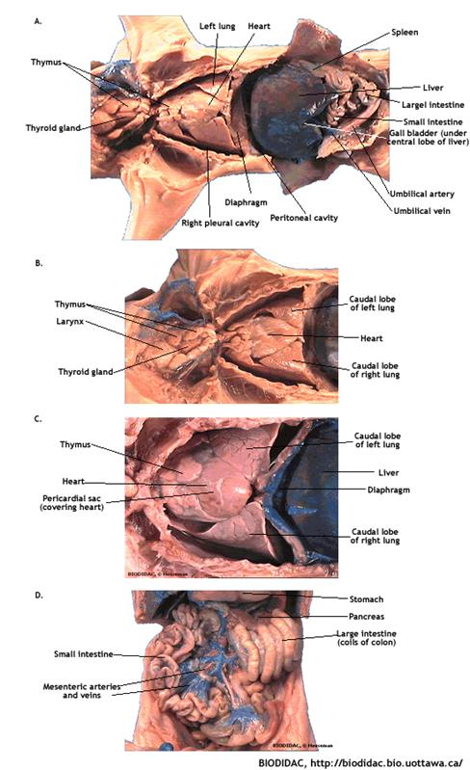

**Figure 5.**  Views of the internal organs of the fetal pig.  A.  Neck, thorax, and abdomen, as they appear after just opening, with no disturbance. B.  Close-up of neck region.  C. Close-up view of thorax.  D. Abdomen, view of intestines.

            The colon (large intestine) can be divided into three major regions:  ascending, coiled, and descending.  The colon runs from the caecum to the rectum.  As with the small intestine, examine a small piece of colon under a dissecting scope.  **How does the internal surface compare with that of the small intestine?**  The colon functions to absorb water for compaction of the feces.  Just past the rectum is the anus, the site of the final muscles of the alimentary canal, the anal sphincter.

**Other Associated Organs**

            The liver, the largest organ in the abdominal cavity, has a multitude of functions, most of which are underappreciated.  For example, in the fetus, blood cell production takes place in the liver as well as the bone marrow.  In the adult, the liver:

* Synthesizes bile, plasma proteins (prothrombin, fibrinogen, albumin), lipids, and cholesterol.
* Stores vitamins, iron, and glycogen.
* Converts glucose to glycogen, glucose to fat, glycogen to glucose, lactic acid to glycogen, excess amino acids into carbohydrates and fats (producing ammonia in the process), and ammonia (a toxic nitrogenous waste) to urea (a less toxic form).
* Recycles hemoglobin components (and excretes bile pigments).
* Detoxifies chemicals, pollutants, and poisons.

            The gall bladder, a small, usually greenish sac which lies on the underside of the right central lobe of the liver, stores bile secreted by the liver.  Bile from the liver enters the common bile duct via the hepatic duct; bile from the gall bladder enters via the cystic duct.  Pick away at the surrounding tissue to find these structures.  Bile is composed of bile salts (which emulsify fats (breaks them into small droplets) in the duodenum) and bilirubin, which is a bile pigment.  Bilirubin is a byproduct of the breakdown of hemoglobin from old red blood cells, which takes place in the liver and spleen.

Locate the pancreas, an elongate granular mass between the stomach and the small intestine.  Actually the pancreas consists of two lobes:  one that runs transversely and another than runs longitudinally along the duodenum.  The pancreas secretes digestive enzymes and other substances into the small intestine via the pancreatic duct (which you will not be able to see).  Remember, the pancreas is an endocrine as well as an exocrine organ.  Endocrine glands have no ducts; they secrete their products (hormones) directly into capillaries.  Hormones act as chemical signals to mediate other physiological processes.  Scattered throughout the exocrine tissue of the pancreas are small islands of endocrine tissue (Islets of Langerhans).  Although these islets are too small to see with the naked eye, they are extremely important.  They secrete insulin, glucagon, and somatostatin directly into the tiny blood vessels that run through the pancreas.  Insulin and glucagon lower and raise blood glucose levels, respectively, and somatostatin regulates levels of both insulin and glucagon.

The spleen is a long, flat, red-brown organ which lies across the stomach.  It is not part of the digestive system and is actually the largest organ of the lymphatic system.  It stores and releases red bloods cells into the bloodstream, recycles old red blood cells from circulation, and aids in the development of white blood cells.  Despite all of these important functions, your spleen can be removed with few ill effects.  **What organs pick up the slack?**

**Think about it????**

1.      Saliva contains water (to moisten food), mucus (to lubricate food), salivary amylase (to break down starch), bicarbonate (to buffer acids in food), and antibacterial agents.  Why might these last three components be necessary when the stomach is the next destination anyway?

2.      Everyone knows different parts of the tongue are especially sensitive to different tastes.  But why should we devote tongue space to bitterness?

3.      In humans, the uvula hangs as a pendant from the posterior end of the soft palate.  During swallowing, it lifts upward and closes off the nasopharynx.  Why is this important?

4.      Is diarrhea a defense strategy to rid your body of pathogens or a way for intestinal pathogens to spread to others (still occurs in less developed countries with no sewage treatment)?

5.      In olden days, coal miners often suffered from rickets, a disease characterized by brittle bones.  Miners rarely see the sun, a "source" of vitamin D.  What's going on here?

6.      Would you expect carnivores to have longer or shorter intestines than herbivores?

7.      What happens if the contents of the colon pass too rapidly through the colon?  too slowly?

8.      What are some possible advantages and disadvantages of foregut and hindgut fermentation?

**III. RESPIRATORY SYSTEM**

**Objectives**

1.   Identify and describe the function of the main organs and structures in the respiratory system.

2.   Describe the movement of air into and out of the lungs.

3.   Apply this knowledge to organismal adaptive strategies and problems in human physiology.

The respiratory system is responsible for bringing a fresh supply of oxygen to the blood stream and carrying off excess carbon dioxide.  In mammals, air enters the body through the external nares and enters the nasal cavities dorsal to the hard palate. As air passes through these convoluted cavities, it is humidified and warmed to body temperature and dust is caught in the mucus of the membranes that line the cavities.  Air moves from here into the nasopharynx, where it passes through the glottis into the larynx.  Carefully cut the soft palate longitudinally to examine the nasopharynx of your specimen.

The larynx is a hard-walled chamber composed of cartilaginous tissue.  In the course of hominid evolution, the larynx has moved downward (caudally).  As a result, human vocalizations tend to come out of the mouth, where the tongue can manipulate them.  In chimps, the larynx is higher in the throat, with the result that vocalizations are very nasal (and thus less controllable and understandable).  Our descended larynx comes with a price – it makes choking on food far more likely.  Interestingly, human babies retain an elevated larynx.  It makes baby talk difficult, but it also allows babies to nurse and breathe at the same time.

Slit the larynx longitudinally to expose the vocal cords.  The vocal cords are elastic ridges that stretch across the space within the larynx.  When air passes over the vocal cords during exhalation, the cords vibrate and produce sound. In adult humans, laryngitis results from viral infection of the vocal cords.  They swell and regular speech is difficult to impossible.

Read the following information about the respiratory system.  However, do not attempt to identify structures other than the trachea until you have exposed the heart and its major vessels (see **Circulatory System** further below).

            The trachea, distinguished by its cartilaginous rings (incomplete on the dorsal side), divides into the two bronchi (singular bronchus), which enter the lungs and divide into bronchioles (don’t try to find the bronchi until you’ve finished examining the heart and its major vessels).  Bronchioles terminate in alveoli, where gas exchange takes place.

            The right lung typically consists of four lobes and the left of two or three.  How many does your pig have?  The lungs in your fetal pig are small and fairly solid because they have never been inflated.  Inflation causes lungs to have a spongy appearance.  Note the position of the diaphragm in relation to the lungs.  Contraction of the diaphragm enlarges the thoracic cavity and pulls air into the lungs.  Remember that only mammals have a true muscular diaphragm; other terrestrial vertebrates use a variety of methods to inflate their lungs.

            Examine the lungs and note the pleural membranes (one lining the inner surface of the pleural cavity and the other covering the outer surface of the lung).  As mentioned earlier, the intrapleural space is filled with fluid.  This fluid allows the membranes to slide freely across each other, much like two wet panes of glass (easy to slide, hard to separate), and allows them to maintain contact.  This ensures that the lungs will inflate when the thoracic cavity expands as a result of diaphragmatic contraction or expansion of the rib cage.

            When neonatal mammals inhale for the first time, their lungs inflate.  When they then exhale, the lungs don’t deflate all the way.  That’s because pulmonary surfactants reduce the surface tension of water (just like soap does – you can float a bottlecap on water until you add a surfactant like soap).  In this case the water is in the form of a film that coats each and every alveolus.  If it weren’t for these surfactants, the surface tension of this layer would collapse the delicate alveoli – causing the lungs to “collapse” after each breath.  This surfactant is produced by the lungs during the last part of pregnancy.

**Think about it????**

1.      Why does the trachea have cartilaginous rings?

2.      Why is it important for air to be moist when it enters the lungs?  Many desert mammals have extremely convoluted nasal cavities.  How might these large and complex nasal cavities conserve water during exhalation?

3.      When you catch a cold, you get a runny nose.  Is snot your body’s way of combating a viral invader, or is the virus simply using you to reproduce and spread itself?  The common cold generally doesn't land you in bed:  is this evidence of you're own abilities to "fight" the virus, or is the virus manipulating you to maximize its exposure to uninfected individuals?

4.      What is the function of the eustachian tubes?

**IV. CIRCULATORY SYSTEM**

**Objectives**

1.   Identify and describe the function of the main organs and structures in the circulatory system.

2.  Trace the flow of blood through the pulmonary and systemic circuits.

3.  Describe how the circulatory and respiratory systems work together to bring about the integrated functioning of the body.

4.  Understand portal circulation.

5.  Understand mammalian fetal circulation from a mechanical, physiological, and evolutionary perspective.

The circulatory (or cardiovascular) system is responsible for transporting nutrients, gases, hormones, and metabolic wastes to and from individual cells.  Actually, the loading and unloading take place in capillaries.  Oxygen is added to the blood (and carbon dioxide removed) in the capillaries of the lungs.  In the capillaries of the small intestine, nutrients are added to the blood, while in the capillaries of the kidneys the blood is cleansed of various metabolic wastes and excess ions.

 In mammals, the circulatory system is divided into a pulmonary circuit, which involves blood flow to and from the lungs, and the systemic circuit, which involves blood flow to and from the rest of the body.  Your pig has been doubly injected (red for arteries, blue for veins).  However, note that in reality, arteries and veins are defined by the direction of blood flow, not by the oxygen content of the blood contained therein.

**1.  The Heart (Fig. 6)**

            You may remove as much thymus as you need to in order to view the heart.  Carefully remove the pericardial sac from the heart.  In living animals, the pericardial cavity is filled with fluid that acts as a shock absorber to protect the heart from injury.  Identify the coronary artery and coronary vein lying in the diagonal groove between the 2 ventricles.  These vessels supply and drain the heart (the heart is a muscle and as such has the same requirements of any other organ).  When the coronary artery becomes obstructed, a heart attack may occur.  It is the coronary arteries that are "bypassed" in coronary bypass surgery.  Note that the atria have external flaps, known as auricles.

            In an adult mammal (fetal circulation will be discussed below), deoxygenated blood flows into the right atrium from the anterior and posterior vena cavae.  It then makes the following circuit:  right ventricle, pulmonary trunk, pulmonary artery, lungs, pulmonary vein, left atrium, left ventricle, aortic arch, aorta, and on into the systemic circulation.  On the heart model, trace this path and find the above as well as the following structures:

* right atrioventricular valve
* atrioventricular valve
* right semilunar valve (between right ventricle and pulmonary trunk)
* left semilunar valve (between left ventricle and aorta)
* papillary muscles:  support chordae tendinae
* chordae tendinae:  support AV valves, preventing eversion

**2.  Major veins of the systemic circulation, anterior to the heart (Fig. 7a)**

            Following the path of deoxygenated blood, find the external jugular vein, which drains the head and neck, and the internal jugular vein, which drains the brain.  Note the vagus nerve running between the right common carotid artery and the internal jugular vein (the vagus nerve is responsible for slowing the heart, constricting bronchi, and stimulating the stomach and gallbladder).  The jugular veins meet with the subclavian vein to form the brachiocephalic vein.  The right and left brachiocephalic veins join to form the anterior (cranial) vena cava.  Note, however, that the mass of veins (and arteries) anterior to the heart may not look exactly like what you see in the figure.  For example, do the external and internal jugulars join before reaching the brachiocephalic?  Does your pig even have a subclavian vein? or do the subscapular (from the shoulder) and axillary (from the arm) veins empty straight into the brachiocephalic vein?  How substantial is the brachiocephalic vein?  or do the subclavian and jugulars empty straight into the vena cava?  Make sure you examine other pigs to appreciate the variability of these vessels.

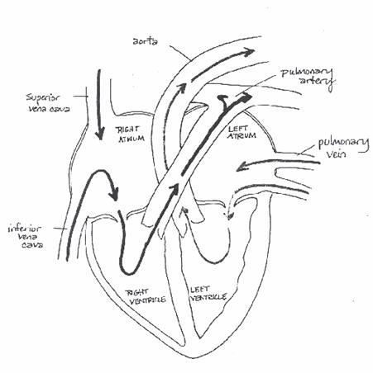

**Fig. 6.** The heart and major arteries and veins.

**3.  Major arteries of the systemic circulation, anterior to the heart (Fig. 7b)**

            Viewing the major thoracic arteries may require moving (but not removing) some of the thoracic veins (attempt the former before resorting to the latter since you will see them on the lab practical).  Like the veins, however, there is a great deal of variation in the branching patterns of the brachiocephalic trunk and the left subclavian artery.  The first large vessel that branches from the aortic arch is the brachiocephalic trunk.  This artery soon branches into the right subclavian and the common carotid arteries (as well as sending vessels along the inner and outer walls of the rib cage).  The subclavian arteries carry blood to the forelimbs, the carotid arteries carry blood to the head.  The carotid branches into an internal carotid, which goes to the brain, and the external carotid, which goes to the face.  In desert-dwelling ungulates, the internal carotid forms an arterial "capillary" bed (rete) over the nasal passages and then reforms the carotid artery and delivers blood to the brain.  Because the nasal passages represent the intersection of hot dry outside air and moist internal body surfaces, a great deal of evaporative cooling takes place there.  Instead of expending energy (and water) to cool their entire bodies, these mammals can allow their bodies to heat up to brain-damaging temperatures while their brain's blood stays cool.

            The second large vessel that branches from the aortic arch is the left subclavian artery.  Note how the branching of the arteries is less symmetrical than that of the veins.

**4.  Major arteries of the systemic circulation, posterior to the heart (Figs. 8, 9)**

            Move the internal organs to view the pig’s left kidney area.  Pick away the connective tissue to expose the aorta just below the diaphragm and find the coeliac artery.  It branches off the aorta to supply the stomach, spleen, and liver.  Huh?  but the coeliac is so tiny!  So the liver, the largest

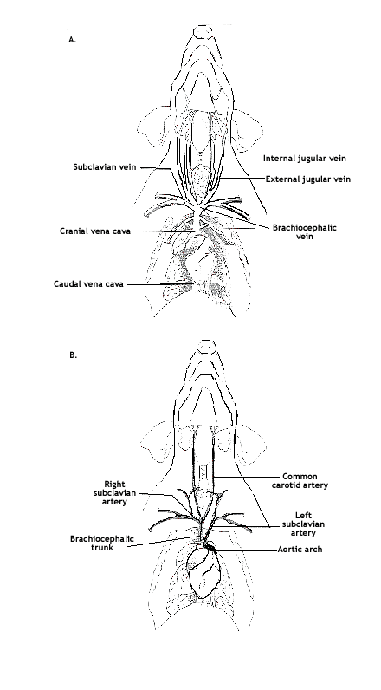

**Figure 7.**  A. Major veins anterior to the heart.

B. Major arteries of systemic circulation anterior to the heart.

organ in the body, is supplied by a mere branch of a rather small artery!  Well, it's more complicated than that.  First, the liver also gets blood from the hepatic portal vein (see below).  “But that's a vein" you say.  And you are correct.  But so much blood flows through it ... and the intestines aren't always a super metabolically active organ, so the liver can benefit from it (and it certainly benefits nutrient-wise).  The other trick is that despite its size, the liver is not particularly metabolically active.  At any given time, only a small proportion of its cells are doing anything.  So that, plus the fact that the liver is really weird in having sinusoids rather than proper capillaries, allows it to work as it does.

Just posterior to the coeliac artery, you will find the cranial (superior) mesenteric artery, which supplies the pancreas and small intestine.  Watch out!  Make sure you find the crescent-shaped adrenal gland before you go digging for the cranial mesenteric artery.  Don’t worry.  Your pig has two, so you can look at the adrenal on the right later.  Also note the lobe of the pancreas situated just ventral to the cranial mesenteric.

At the kidneys, short renal arteries supply blood to the kidneys.  At the caudal end of the abdominal cavity, you can see several branches of the aorta.  The external iliac arteries are the main arteries of the hindlimbs.  The tiny internal iliac arteries, which supply the rectum and hip, can be found where the aorta branches to form the two umbilical arteries.

**5.  Major veins of the systemic circulation, posterior to the heart  (Figs. 8, 9, 10)**

            In the lower abdominal cavity, find where the external iliac vein and internal iliac vein join to form the common iliac vein.  The right and left common iliac veins then join to form the posterior vena cava. Find the renal veins.

**6.  The hepatic portal system (Figs. 8, 9)**

            In a normal circulatory pathway, blood takes the following path:  artery – capillary bed – vein.  In a portal system, the blood travels in the following manner:  artery – capillary bed – portal vein – capillary bed – vein.  Portal systems are found in many different parts of the body and carry blood from the capillaries of one organ to the capillaries of another organ.  In the case of the hepatic portal system, nutrient-rich blood from the mesenteric veins flow into a single mesenteric vein, which joins with the lienogastric (gastrosplenic) vein from the spleen and stomach and becomes the hepatic portal vein.  This vein now carries blood to the liver, where it breaks into a second capillary bed.  Here the products of digestion pass into liver cells.  This ensures that the liver has "first shot" at toxins from the diet as well as glucose, amino acids, and lipids.  Capillaries in the liver then converge into the hepatic veins, which empty into the caudal vena cava for transport back to the heart.  If the intake of toxins (such as alcohol) exceeds the liver's ability to filter them from the blood, the excess enters the general circulation and on to other organs (like the brain).

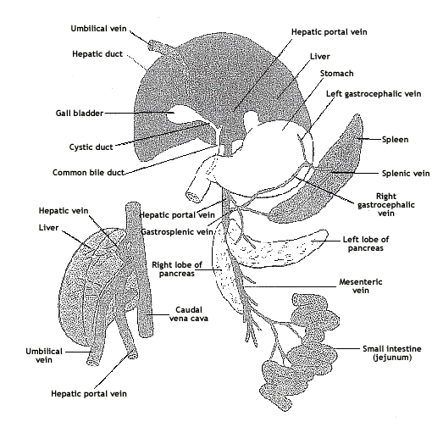

**Figure 8.**  Illustration of hepatic portal system depicting associated veins and organs.

**7.  Fetal Circulation**

            The amniotic egg is characterized by a yolk sac, a chorion, an allantois, and an amnion, and was one of the keys to the success of the early reptiles (and their descendents – the modern reptiles, birds, and mammals).  In a standard amniotic egg (think chicken egg), the yolk sac provides the nutrition for growth, the amnion provides a watery medium to float in, the allantois provides a sac to contain and isolate nitrogenous wastes, and the chorion surrounds all and is the means by which oxygen diffuses in to the embryo.  Live birth and placentas have evolved multiple times within the Amniota.  This is just a fusion of the chorion and amnion which lies against a highly vascularized uterine wall.  Nutrients and oxygen diffuse from maternal capillaries, across these two thin membranes, and into fetal capillaries on the fetal side of the chorion-amnion barrier.  Carbon dioxide and nitrogenous wastes diffuse out of fetal capillaries and across into maternal blood.  **Fetal and maternal blood never mix** (this is why mothers and their children can have different blood types).  In pigs, nutrients and gases must diffuse across maternal capillary walls, the uterine tissue, the chorion, and finally the fetal capillary walls.  In humans (and other primates), the uterine wall and maternal capillaries break down, forming open blood sinuses.  Thus in humans, fetal capillaries are separated from sloshing maternal blood by only a thin chorionic layer. Keep in mind that fetal tissues are not as well oxygenated as maternal tissues.

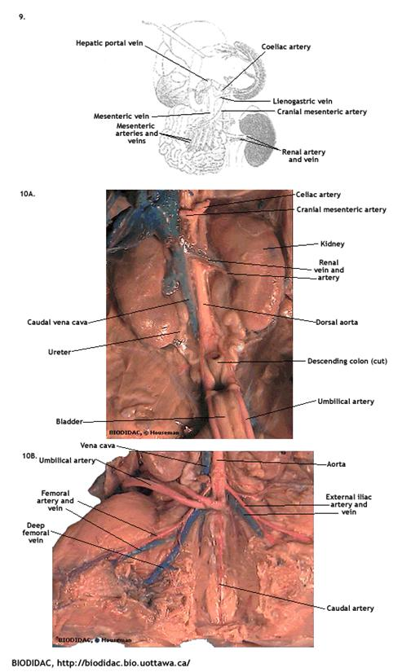

**Figures 9 and 10.** 9. Hepatic portal system.  10A. Fetal and renal circulation.  10B. Posterior circulation.

The umbilical vein carries oxygen- and nutrient-rich blood from the fetal side of the placenta to the fetus.  However, this relatively well-oxygenated blood mixes with deoxygenated fetal blood before it enters fetal arterial circulation.  The first site of mixing is within the liver.  The umbilical vein enters the liver and its sinusoids, but as a result of the increasing blood volume as the fetus develops, essentially clears a path through the liver tissue.  The resulting channel is known as the ductus venosus.  Oxygenated venous blood from the liver (from the hepatic portal system as well as hepatic veins) is mixed in the ductus venosus and continues on to the caudal (posterior) vena cava.  Here it mixes with deoxygenated blood from the rest of the body on its way to the heart.  Finally, within the right atrium, this blood is once more mixed with deoxygenated blood, this time from the cranial (anterior) vena cava.

            How do mammalian fetal tissues survive in such a low oxygen environment?  The answer lies in their red blood cells.  Fetuses have a different kind of hemoglobin than do adult mammals.  Fetal hemoglobin has a higher affinity for oxygen than does adult hemoglobin; it is still able to pick up oxygen molecules when environmental oxygen levels are very low (levels at which maternal hemoglobin is shedding oxygen).  On the flip side, fetal hemoglobin holds oxygen until tissues are on the verge of oxygen deprivation.

            In the fetus, the pulmonary circuit is not functional and is therefore bypassed.  About half of the blood entering the right atrium flows directly into the left atrium via the foramen ovale (it is not necessary for you to find this small opening, but you can try).  From here it moves into the left ventricle, then the aorta, and out into the systemic circulation.  The remainder of the blood entering the right atrium flows into the right ventricle and out to the pulmonary trunk.  However, instead of flowing on to the pulmonary artery and the lungs, this blood bypasses the pulmonary artery and goes through the ductus arteriosus into the aorta, where it enters systemic circulation.

            So fetal tissues never have the benefit of contact with highly oxygenated blood.  And actually, it’s worse than that.  Because maternal blood doesn’t give up all that much oxygen to the placenta.  So how do mammalian fetal tissues survive in such a low oxygen environment?  The answer lies in their red blood cells.  Fetuses have a different kind of hemoglobin than do adult mammals.  Fetal hemoglobin has a higher affinity for oxygen than does adult hemoglobin; it is still able to pick up oxygen molecules when environmental oxygen levels are very low (levels at which maternal hemoglobin is shedding oxygen).  On the flip side, fetal hemoglobin holds oxygen until tissues are on the verge of oxygen deprivation.

            In late fetal life, the foramen ovale becomes smaller relative to the rest of the heart and the lumen of the ductus arteriosus narrows, forcing more blood through the pulmonary circuit.  At birth, decrease of blood flow through the right atrium and the decreased resistance within the pulmonary circuit has several effects.  First, pressure between the two atria equalizes, closing the flaps of the foramen ovale and allowing it to seal itself.  Second, the decreased resistance of the pulmonary circuit directs blood in the pulmonary trunk toward the lungs.  This causes some of the blood leaving the heart through the aorta (blood that has already been partly aerated by having passed through the lungs) to re-enter the pulmonary artery by the ductus arteriosus and pass through the lungs a second time.  Double circulation lasts only a day or so, after which the ductus arteriosus contracts and fills with connective tissue.

            So…to review… the most oxygenated blood is in the umbilical vein.  It mixes (rather counterintuitively) with the very deoxygenated blood of the posterior vena cava.  Thus the posterior vena cava just posterior to the heart is more oxygenated than the anterior vena cava just anterior to the heart.  The aorta is thus less oxygenated than the anterior portion of the posterior vena cava!  Even more strange, the aorta sends a great deal of rather oxygenated blood straight back to the placenta (via the umbilical arteries).  You’d think the fetus would send deoxygenated vena cava blood to the placenta to get oxygen, but nope!  It sends oxygenated aorta blood!  Remember though, the blood pressure in the vena cava is essentially zero … and that capillary beds work better when there is a blood pressure differential between the arterial and venous sides.  The aorta provides that blood pressure.

**Think about it????**

1.      Why are the larger arteries white rather than red?  Why are the large veins nevertheless blue?

2.      The dual circulation of mammals is reflected not only in separate pulmonary and systemic circulatory systems, but also in the four-chambered heart.  Fish blood leaves the heart, goes to the gills for oxygenation, and then continues out to the body.  How many atria do fish have?  How many ventricles?

3.      Some salamanders that "breathe" (exchange gases) through their damp skins have lost their lungs.  Do you think their hearts have one or two atria?

4.      What might happen if the ductus arteriosus fails to close completely in the days after birth?  The foramen ovale?

5.      The condition known as jaundice (yellow skin and eyes) is a result of a build-up of bilirubin and is usually a sign of liver malfunction.  Newborn human infants often go through a period of fetal jaundice in which they turn yellow.  This usually reflects not a liver malfunction, but rather the destruction of huge numbers of red blood cells.  Why would newborns be cashing in so many red blood cells?  In serious cases, neonates are often put under special lights that promote the breakdown of bilirubin.  However, recent evidence demonstrates that bilirubin is a potent anti-oxidant.  Why would a neonate need so many anti-oxidants?

6.      Is the blood within a fetus’s hepatic portal vein nutrient rich?

7.      Why are so many alcoholics signed up for liver transplants?

**V. UROGENITAL SYSTEM**

**Objectives**

1.   Identify and describe the function of the excretory system of the fetal pig, noting differences between the sexes and noting structures shared with the reproductive system.

2.  Identify and describe the function of the reproductive systems of male and female fetal pigs and trace the pathway of sperm and egg from their origin out of the body.

**Excretory System**

            The bean-shaped kidneys (Fig. 11) perform two functions.  First, they continuously remove metabolic wastes from the blood (primarily urea resulting from the metabolism of amino acids in the liver).  Second, they monitor and adjust the composition of the blood (particularly water and salts) so that the cells of the body are bathed in a fluid of constant composition.  Although the kidneys are situated below the diaphragm, they are actually located outside the peritoneal cavity (dorsal to the parietal peritoneum, the membrane that lines the abdominal cavity).  Carefully cut one of the kidneys in half longitudinally (slice it as though you were separating the two halves of a lima bean).  Within the kidney, the ureter expands to form a funnel-shaped chamber called the renal pelvis.  The dark kidney tissue that you see extending into the renal pelvis is known as medullary tissue (medulla).  The outermost portion of the kidney is called the cortex.  The cortex contains glomeruli, Bowman’s capsules, proximal convoluted tubules, and distal convoluted tubules.  The medulla contains the loops of Henle and the collecting ducts.  The medulla is characterized by high solute concentration, so when "pre-urine" flows down the loops of Henle, water flows out of the loops and into the medullary tissue.  The net result of this (and a few other processes of the medulla) is that the "urine" becomes increasingly concentrated.  In humans, the kidneys filter 1500 liters of blood a day, producing only about 1.5 liters of urine in that time.

            Near (but usually not actually on) the anterior/medial edge of each kidney lies a narrow band of light colored tissue, the adrenal gland (adrenal means "near or adjacent to the renal [kidney])".  The adrenals may be difficult to see, especially in smaller pigs.  Despite it's subtle appearance, the adrenal gland is one of the most bizarre and important glands in the body.  The cortex is epithelial in origin; the medulla is neural!  In fact, the cortex and medulla are not even united in some vertebrates.  The outer layer of the adrenal cortex secretes aldosterone, an important hormone for water balance.  The middle cortex produces glucocorticoids like cortisol.  These “stress hormones” have a variety of effects ranging from carbohydrate balance to immunosuppression.  The inner cortex produces androgens, even in females.  These androgens are involved in the growth spurt, development of pubic hair during puberty in girls.  The adrenal medulla, being of neural origin, produces norepinephrine and epinephrine (aka adrenaline), which are neurotransmitters.  When released, these adrenal hormones produce the fight or flight response, mobilize glucose, and increase heart rate.

The renal pelvis of each kidney drains into a coiled tube called the ureter.   The ureters lead from the kidney to the urinary bladder, where urine is temporarily stored.  Note the unusual shape (elongated) and location (between the umbilical arteries) of the urinary bladder in your fetal pig.  In fact it extends into the umbilical cord!  Urine produced by the fetus actually bypasses the urethra (the tube that transports urine from the bladder to the outside of the body).  If a fetus urinated in an adult manner, the amnionic sac would soon be fouled with toxic nitrogenous wastes (urea is toxic).  Instead, urine produced by the fetus proceeds from the bladder through the allantoic duct and to the allantois (a special sac for nitrogenous wastes).  But remember that most nitrogenous wastes are transported to the placenta via the umbilical arteries.  However, even in reptiles and birds, the allantois takes on a dual function.  In addition to storing nitrogenous wastes, it fuses with the chorion to create a vascularized membrane that mediates gas exchange.  In mammals, this latter diffusion function takes place in conjunction with the placenta, as does nutritional exhange and waste removal. In both pigs and humans, the allantoic duct collapses at birth and urine flows from the bladder into the urethra.

            To follow the urethra to the urogenital opening, you will have to also examine the reproductive system, as they are linked together.  Examine the urogenital system in your pig.  Then examine a pig of the opposite sex.  You are responsible for both male and female anatomy.

            To examine the urethra and the reproductive structures fully, you will need to carefully cut through the pelvis (pubic bone or pubis) of your pig.  Don’t make this cut without consulting me.  Make sure you keep your cut slightly to the left or right of the midline to avoid cutting important structures.

**Female Reproductive System (Fig. 11)**

            In the female, the opening of the urogenital sinus / vaginal vestibule lies directly ventral to the anus.  It is bounded laterally by low folds, the labia, which come together ventrally to form a protruding genital papilla.  The clitoris, a small body of erectile tissue on the ventral portion of the urogenital sinus, may be visible.  The clitoris is homologous (similar in structure and developmental origin) to the male penis.  In the male, the tissues of the penis develop around and enclose the urethra, while in the female the urethra opens posteriorly to the clitoris.

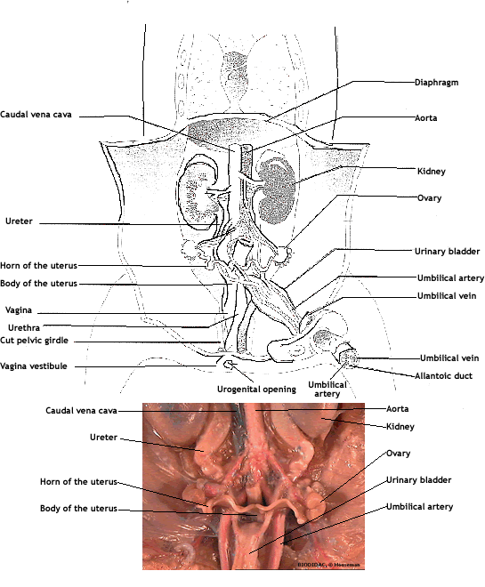

**Figure 11.** Kidneys, excretory system, and female reproductive system.

            Within the body of the female, the urethra is bound by connective tissue to the vagina.  Gently separate this tissue.  The vagina and the urethra join together about 1 cm from the exterior body opening to form the urogenital sinus / vaginal vestibule.  This structure is not present in adult females--separate external vaginal and urinary openings begin to develop after birth as the urogenital sinus shrinks.  **How might this occur?**

            Trace the vagina anteriorly to the cervix, a slightly constricted region of tissue which leads to the uterus (did you know that 99% of cervical cancers in humans are due to viral infection?).  The cervix acts as a sphincter to separate the vagina from the uterus.  It's usually closed.  In fact, the female mammalian reproductive system has many safeguards against sexually transmitted disease:  an acidic vagina, antibacterial mucus, and lots of white blood cell activity.  **Why are such safeguards especially important in humans?** The uterine body branches anteriorly into two uterine horns (pigs and many other mammals have a bicornate uterus; humans have a simplex uterus).  Another feature of uterine horns is the production of litters (incidentally, pigs are the only ungulates that produce litters).  Trace the uterine horns to the oviducts, where fertilization normally takes place.  These tubes are much smaller than the horns and lie extremely close to the ovaries.  The ovaries are the sites of egg production and the source of female sex hormones, estrogen and progesterone.  Every egg (actually primary oocyte) that a female pig (or human) will ever produce is already present in the ovary at the time of birth.

**Male Reproductive System (Fig. 12)**

Bear in mind that the testes, the site of sperm and testosterone production, are found in the scrotum in older fetuses, but may remain undescended within the body cavity in younger fetuses.   The following instructions/discussion assumes descended testes.

            First, make a midline incision into the scrotum.  Pull out the two elongated bulbous structures covered with a transparent membrane.  This membrane is actually an outpocketing of the abdominal wall.  The gubernaculum is the white cord that connects the posterior end of the testes to the scrotum wall.  It grows more slowly than the surrounding tissues and thus "pulls" the testes into the scrotum.

            Cut through the tunica vaginalis to expose a single testis and locate the epididymis, a tightly coiled tube along one side.  Sperm produced in the testis mature in the epididymis until ejaculation.  Unlike females, male mammals are not born with a lifetime supply of gametes.  Sperm are produced only after puberty, but then continue to be produced for the rest of the life of the male.  Cells within the testis (but not those that give rise to sperm) are responsible for the production of testosterone.  Evidence suggests that sperm may not be recognized as “self” by the immune system and must therefore be protected.  Not only is there a blood/testis barrier (just like there is a blood/fetus barrier in females), but also the immunosuppressive characteristics of testosterone are no accident.  The testosterone produced within the testes by the interstitial cells that physically surround the spermatogenic cells provide a strong defense.

            The slender elongated structure that emerges from each testis is the spermatic cord.  It goes through the inguinal canal (actually an opening in the abdominal wall connecting the abdominal cavity to the scrotal cavity).  It is through this canal that the testes descend.  The spermatic cord consists of the vas deferens (plural vasa deferentia), the spermatic nerve, and the spermatic artery and vein. The vasa deferentia are severed in a vasectomy.

            Expose the full length of the penis and its juncture with the urethra.  Make an incision with a scalpel through the muscles in the midventral line between the hindlegs until they lie flat.  Carefully remove the muscle tissue and pubic bone on each side until the urethra is exposed.  With a blunt probe, tear the connective tissue connecting the urethra to the rectum, which lies dorsal to it.

            Locate the seminal vesicles on the dorsal surface of the urethra where the two vasa deferens enter.  The seminal vesicles are responsible for 60% of the volume of the seminal fluid.  They release fructose to provide energy for the swimming sperm and prostaglandins and clotting factors to aid in the mass movement of the ejaculate up the female reproductive tract.

            Situated between the bases of the seminal vesicles is the prostate gland.  This gland produces bicarbonate, an alkaline substance, to neutralize the acidic environment of the vagina.  The bulbourethral (Cowper's) glands lie on either side of the juncture of the penis and urethra--their precise function is poorly understood, though they also produce an alkaline solution.  The urethra joins the penis just posterior to the Cowper's glands.  The retractable penis extends through the tissue of the "flap" that holds the bladder to the urogenital opening.  Use your finger to feel the penis within the flap.  Carefully pick away the tissue in this area to separate the penis.

**Think about it????**

1.      Would you expect to find corpa lutea on the ovaries of a fetal pig?  Why or why not?

2.      Why do most male mammals have testes in an external sac (scrotum)?  (Hint: there is some evidence that men that wear briefs produce fewer viable sperm than men that wear boxers).  Why might some mammals pull their testes back into their body in the non-breeding season?

3.      The spermatic artery and vein don't just traverse the same canal.  They are so closely associated with one another that they exhibit countercurrent properties – not only do they run side by side through the inguinal canal, they also form a rete by which venous blood is warmed and arterial blood is cooled.  Why is this necessary?

4.      What is the difference between the ejaculate of a vasectomized man and a man who has not undergone this procedure?  Do vasectomized men continue to produce testosterone, and if so, by what path does it get into the general circulation?

5.      Some human males develop an inguinal hernia, a condition in which part of the intestine drops through the inguinal canal into the scrotum.  Pigs and other quadrupeds do not develop inguinal hernias.  Why not?

6.      Although you may not be able to distinguish it, the thoracic cavity of your pig contains brown fat.  This is a special type of adipose tissue that, when metabolized, produces a great deal of heat (it’s chock full of mitochondria).  Birth triggers the metabolism of brown fat in mammalian neonates.  Why does a newborn mammal need such a heat source?

7.      The rectus abdominus muscle is the main muscle of the abdominal region.  Until the early 1980's, women who gave birth via Caesarian section were opened up with a longitudinal cut down the midline of their abdomen.  Since then there has been a shift for C-section incisions to cut across the bottom of the belly (i.e. right to left).  Cutting a muscle perpendicular to the “grain” is much more damaging to it than a cut along the length of the muscle (“with the grain”).  Why is it that obstetricians now cut in this seemingly more damaging direction?

ACKNOWLEDGMENTS

Dr. Mark Stanback developed this dissection exercise. Dr. Chris Paradise enhanced all figures using Fireworks.  The following sources were used in the development of the exercise and figures:

BIODIDAC.  The BIODIDAC Project, A bank of digital resources for teaching biology.  [http://biodidac.bio.uottawa.ca](http://biodidac.bio.uottawa.ca/). (Figures 1, 2, 3, 5, 10, 11B, and 12C)

Dolphin, W.D. (1988) Zoology laboratory manual.  Benjamin/Cummings, Menlo Park, CA.

McNally, L.  Fetal pig handout.  Biology 112.  Davidson College.

Morgan, J.G., Carter, M.E. (1996) Investigating Biology.  Benjamin/Cummings, New York.  (Figures 6, 7, 8, 9, 11A, 12A, and 12B).

Peroni, P.  Fetal pig handout.  Biology 112.  Davidson College.

Perry, J.W. & Morton, D. (1989) Laboratory Manual for Starr and Taggart's Biology.  Wadsworth, Belmont, CA. (Figure 4)

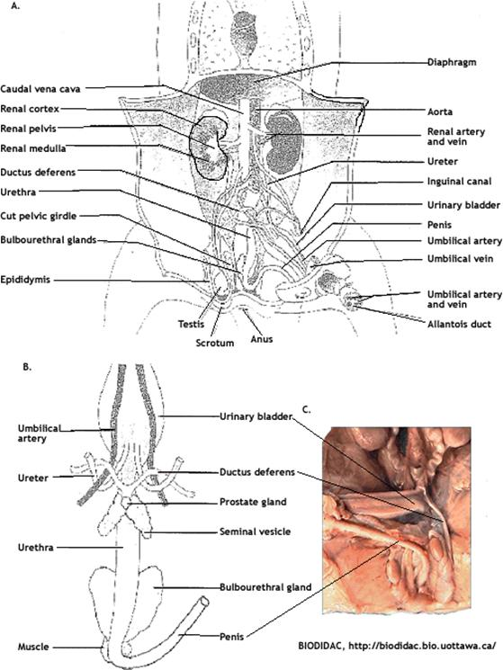

**Figure 12.**  A. Overall schematic of male urogenital system.  B. Close-up of male reproductive system.  C. Photo of male reproductive system.  Label parts that I have not labeled.